المطلوب:
Submit a thorough analysis of each of the 3 artworks.
For each artwork:
* Thorough formal analysis
* Interpret the function and purpose
* Evaluate the cultural significanceAlso add:
* A slide with a bullet point list of connections among the artworks NO COPYING! NO PLAGRISIM

The 3 artworks assigned:
- ‘Head of a Brabant Peasant Women with Dark Cap’ by Vincent Van Gogh

2) ‘Figure with Horn’ by Derek Fordjour

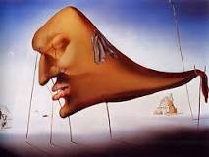
3) Sleep by ‘Salvador Dali’

You can find an example and a step to step guide and an example:

https://sites.google.com/a/hbuhsd.edu/ib-art/analyzing-artwork

https://owlcation.com/humanities/How-to-Write-a-Visual-Analysis-Paper

Due: May 20, 2018

